**CHAPTER 1**

**COMPANY ÓVERVIEW**

* Uni-Solutions was founded in 2006 which provides B2B services, fully comprehensive lead generation and back office services, as well as a complimentary support and inbound call center solution, according to a unique cost-efficient operational model.
* The aim is to simplify the lives of clients and their customers.
* They provide innovative practices and strategies to meet their clients’ very specific requirements, so they can focus on their core business.
* They have corporate locations in Houston, Bangalore and Tel-Aviv, Israel.
* Their two Bangalore offices provides lead generation, international call center services and other outsourcing campaigns to the US, Canada, UK, Israel, Germany, Australia, South Africa and India.
* They believe in doing honest, high quality business while ensuring that each and every one of their customers profits from their services.

**1.1 COMPANY GOALS**

1. **Access the Market:**

They strategically assist you in accessing the market of your choice for your goods and services and help you to achieve the increase in B2B transactions that you desire. Market access is the prerequisite for success not only for start-ups as a once off activity at the start of the brand life-cycle, but it is also relevant for companies looking to expand.

* At Lead to Market, first and foremost we define the market access initiative, setting goals and a clear strategy. In order to implement a solid marketing strategy,
* One must understand that market access is packaging the data in the correct way and communicating it as best as possible to the right prospects. Understanding what the buyer wants and what the buyer’s motivations are is critical to the process.
* Lead to Market is here to assist you in the challenges of launching a new product in today’s competitive markets. The integration activities to access the market in the form of lead generation need to be part and parcel of your company’s mainstream marketing.
* The correct identification of who the key customers are and the best way to access them is essential to successfully open new markets. In Lead to Market terms this process is best defined as “stakeholder mapping”. Furthermore, it is imperative to clearly communicate the economic value and additional benefits of your product.

1. **Open the Sales Pipeline:**

At Lead to Market we measure progress throughout the sales pipeline, from the unqualified lead to the satisfied repeat customer. We assist in initiating a clear sales process or sales funnel to quantify demand for a company’s products and services.

* By effectively managing your sales pipeline, you can regulate customer demand and smooth out the sales cycle to achieve more reliable results.
* Identifying how possible opportunities acquired through lead generation are moving through the sales process, along with the correct charting of progress by means of measuring the target criteria, will allow you to open the sales pipeline.
* In order to improve your sales pipeline, it is critical to begin with enlarging the number of prospects that enter the funnel. If there are no leads entering the pipeline, then there will be no sales coming out of it. The initial step is acquiring quality leads and quality appointments.
* In general, sales teams do not make enough outbound calls to acquire a enough activity in the sales pipeline. Sales teams have the ability to close sales, but they generally find difficulty in conducting the initial cold calls.
* Lead to Market has the expertise to successfully conduct the preliminary contact with prospects with the aim of assisting your sales team in converting the prospects into active customers. This allows for your sales team to focus on profitable opportunities and hopefully close deals faster.

1. **Increase B2B Transactions**

* Lead to Market excels at assisting businesses increase the sale of their products or services to other companies that in turn may use them to support their operations
* Resell them or use them as components in services or goods that they may offer.
* B2B or business to business marketing tactics that are generally used include advertising, public relations, trade show appearances, branding, search engine optimization and most importantly lead generation.
* Creating an efficient sales pipeline early on which incorporates the correct balance of marketing elements will assist you to increase B2B transactions. In addition, a successful lead generation program which shifts the responsibility of outbound calls and the follow-up process from the sales team to the marketing team,
* Which may utilize internal or external resources, will enable your company to be more efficient and reap the B2B sales benefits.
* According to a study conducted by the BMA, Business Marketing Association of America, over $13.2 Billion is spent every year on lead generation efforts including telemarketing and direct mailing, out of a total of $85 Billion spent by companies on promoting goods and services. These numbers justify the relevance and need for a focused lead-gen effort throughout the B2B sector.

1. **Fast Track to New Business**

* If you are looking to grow your new business or acquire new potential clients and start selling, you have reached the right place.
* Generating quality sales leads is a numbers game and is also about momentum there is no time to waste.
* A steady stream of leads needs to be generated and converted in order to open the sales pipeline.
* The beauty of our lead generation operational model is that you decide the pace and standards. All that is left is for us to perform, and we have got that down to a fine art.
* Many entrepreneurs do not have the hours to spare in the start-up phase of a new business and most of them have not mastered the techniques of making successful cold calls/outbound calls and appointment setting following discovery calls.
* If there is currently a small team devoting much needed time and energy into the venture, then you might require external assistance in the lead generation realm.

**1.2** **The Vision and Mission**

**The Vision:**

Is that higher value services could be delivered from the outsourcing capital of the world

**The Mission:**

Is to provide high quality business while ensuring that each and every one of our customers profits from our services.

**OBJECTIVE**

* Discover current trends in integration, spanning application/system, process, B2B, mobile, data, & cloud integration.

**1.3 SERVICES PROVIDED**

1. **Lead Generation:**

Lead to Market prides itself on its tailor-made and cost-effective lead generation service. 00000000000000000000000000000000000000000000000000000000000000000000000000000000000000We are able to provide seamless representation of your company, products, and services, with the aim of acquiring quality leads for your sales team.

* Identify and Engage – Identify the “to go to” people in the ideal companies
* Make our Mark – Establish a memorable dialog
* Qualify the Target –Ask the right questions to establish relevance
* Maintain Connection – Stay engaged with relevant content and timely the conversations until they’re ready to convert – lead nurturing Optimization with Sales Team – Manage qualified lead distribution to your sales staff
* Optimization with Sales Team – Manage qualified lead distribution to your sales staff
* They have trained and experienced inside sales specialists who are pros at learning your products and services. They specialize in being able to use that knowledge to prospect effectively in order to engage decision-makers, qualify their needs, and set appointments on your behalf. Our lead generation teams can deliver your message, uncover opportunities, and motivate high-level executives to take action.

1. **Content Marketing:**

* **LTM has developed a very tightly scripted content marketing program that runs counter to these trends. LTM employs techniques to maintain relevancy, generate engagement and causes an increase in the number of sales cycles active with your sales team. Here are the elements we combine to achieve campaign success.** Content marketing is revenue focused and it is a process of delivering the right info to right audience at right time.
* Using social media, they understand their clients' customers perception of the business problem they need to solve---not just our client’s solution. This is critical for Pipeline building content because early in the buyer’s journey, they have not realized they need the solution proffered by our client. Most clients are great at late stage content and bad at early stage content, and so they fail to expand their pipeline.
* They test our assumptions via survey
* Created a consistent process from content research through content creation all the way to first call sales execution…nobody else does that. The majority of companies just create content and throw it out there in a spray and prey manner. The LTM process is very tightly defined all the way to the first sales appointment.

1. **Demand Generation:**

* Digital marketing encompasses all marketing efforts that use an electronic device. Businesses leverage digital channels such as search engines, social media, email, and their websites to connect with current and prospective customers
* Demand Generation is a marketing program to bring awareness & interest towards company's products and service.

1. It helps to identify one’s target audience.
2. It undergoes creating content, trade show, and to execute viral marketing campaigns.
3. Its primary goal is to drive interest in company's product and convert prospects into customers.

* Lead to Market has perfected a demand generation marketing methodology that has been proven in dozens of successful campaigns across the globe.
* With Lead to market’s Create, Capture & Convert Technique, we collect the prospective customers concerns directly from the target client. We use the most important concerns to target real opportunity and reshape the sales conversation.

1. **Lead Qualification:**

* Our associates will do all the calling and back-end CRM work, allowing you to do more with the same number of Sales representatives.
* Your Lead to Market full time resource will not only qualify the leads that are coming in, but also book discovery calls for your sales representatives, saving them time and increasing overall company revenue.
* Lead Qualification is a process of identifying a lead and qualify them into prospects, it is a process of determining that which lead turns into prospects.
* Some Lead Qualifications:
  + 1. Inbound web leads.
    2. Whitepaper downloads.
    3. Webinar signups.
    4. Trade Show lead generation.
    5. Newsletter sign ups.
    6. Trial product downloads.
    7. Advertising campaigns.

1. **List Generation and Acquisition:**

* Our reps can qualify the leads on your existing prospect lists which you have acquired through the web, via Trade Shows or any other marketing activities.
* This saves countless hours of qualification that your sales and marketing team would have to invest. If the wrong information is present or if the person has left the company and has been replaced, our reps will retrieve the up to date information for you.
* New List Acquisition:
  + - In conjunction with the building of your new inside sales team at Lead to Market, it is important to have a high-quality prospect list to work with. We can work with you in order to acquire the right list to suit your needs from several sources.
* Custom List Generation:
  + - Our business development professionals can conduct research according to your guidelines in order to create lists of prospects from scratch. Our clients can work directly with the inside sales team at Lead to Market in order to maximize the value of your team by providing them with new contacts daily and by adjusting according to feedback.

1. **Back Office Services:**

* Back offices can be outsourced offshore to Lead to Market’s Bangalore offices, where rent and professional labour costs are lower than the US and Europe.
* What our clients can expect in the realms of technical support, inbound call centre requirements, database entry and more, is an updated and systematic management team, with the company knowledge and expertise to perform outsourced back office services and business functionalities for your company.
* These are some of the areas where we can provide you with outsourced back office service:
* General and technical support agents.
* Administrative Duties.
* Order Management.
* Salesforce Management.
* Database Management.
* Inbound / Outbound calls.
* These are the positive aspects of outsourcing your back-office functionalities:
* Reduce your overheads.
* Allows you to focus on core activities of your company.
* Staffing flexibility.
* Incremental progression and risk management.

1. **Marketing Consultancy:**

* We work from strategy to implementation, from the marketing messages that appear on your websites to the marketing campaigns and email templates that go out to your potential clients.
* Lead to Market services include a wide range of marketing tools which may be incorporated alongside a lead generation campaign or that can be implemented on a standalone basis.
* Search Engine Optimization (SEO)
* If you want to show up first in your potential customers’ search engine results page, there is a lot that can be done by simply optimizing your existing content with the correct SEO.
* Lead to Market has the expertise to increase your ranking on vital keywords which will bring your business.
* Search Engine Marketing
* Getting the traffic and conversions you want fast can be achieved through paid search results.
* Lead to Market can get you there with our search engine marketing consultancy.
* If you are looking to access the market and ensure the growth of your pipeline, we can ensure that you are showing up in front of the right people at the right cost.
* Content Marketing
* The number one activity that will ramp up your inbound marketing efforts is content marketing.
* By creating high quality content that your prospects will want to share with their peers, your website traffic will increase dramatically with high quality visits from the relevant people.

1. **Market Research:**

* We conduct tailor-made telephonic and mail surveys with our team of market research specialists who can collect the relevant data from your relevant target groups. Together we can then then use the resulting data to define your potential customers habits and tastes in order to make educated marketing decisions.
* Lead to Market Process of Market Research
* Identification of potential prospects and target markets.
* Defining a problem and the research objectives.
* Development of market research plan.
* Market survey and data collection.
* Information analysis according to predefined criteria.
* Detailed report presentation and creation of qualified database.
* Lead generation follow-up if requested.
* These are the positive aspects of outsourcing your back-office functionalities:
* Reduce your overheads.
* Allows you to focus on core activities of your company.
* Staffing flexibility.
* Incremental progression and risk management.

1. **Digital Marketing:**

* We conduct tailor-made telephonic and mail surveys with our team of market research specialists who can collect the relevant data from your relevant target groups. Together we can then then use the resulting data to define your potential customers habits and tastes in order to make educated marketing decisions.
* Digital marketing is a process of marketing products or services using digital channels search engines, websites, social media, email, and mobile apps.
* Some of the digital marketing pathways:
* Social Media Marketing
* Content Marketing
* Search Engine Optimization (SEO)
* Search Engine Marketing (SEM)
* Pay-Per-Click Advertising (PPC)
* Affiliate Marketing
* Email Marketing
* Radio advertising

**1.4 Projects Undertaken:**

**SharePoint service IT project**

Here is a Case Study of SharePoint Intranet Portal for a MNC Bank

* Bank has close to 14,000 employees and the communication between Employees and the Employer is of greater value to the company.
* SharePoint was an Ideal platform for the Bank to setup an Intranet portal which will be a centralized place, where all the organization related information are shared and managed efficiently.

Features

* **Spotlight**: To showcase the Major events happening within the organization
* **Advertisement**: Section to advertise any specific programs / events.
* **Quick** **Poll**: To conduct a survey within the Organization
* **Stock** **Ticker**: Displays the latest live price of the company stock.
* **Alerts**: Any important messages can be displayed.
* **Custom** **Left** **Navigation**: Quick Navigation to different section in the Intranet Portal.
* **News & Events:** Displaysthelatestnewsacrosstheorganization**.** Itisconfigurableto**,**
* Display Latest News on top.
* Archiving
* Versioning
* Set news approval workflow before displaying the news to the end user

**FMT Systems of Texas, Inc.**

**Situation**

Organization implemented ERP software that didn’t integrate well with its business processes.

**Task**

Assess business processes and software installation and make recommendations for improvement.

**Actions**

Identified, documented, and evaluated company’s business processes. Assessed the ERP software. Conducted a gap analysis on processes and software. Mentored business community and IT.

**Result**

Reduced software customizations by 80%. Reduced system outages by 25%. SDLC and QA programs were established.

**CONFER CYBER THREAT PREVENSION NETWORK**

**Cyber Threat Prevention Network**

* Confer is a wire speed, collaborative threat-based defense designed to protect laptops, desktops,
* servers and mobile devices from sophisticated attacks.
* Enterprise Protection-Lightweight Experience
* SaaS-Based Architecture
* Easy to implement and manage 10,000+ endpoints from a single administrator login
* Always-on coverage protects users even when connecting to untrusted networks
* Cloud based analytics and threat detection results in no signature database to maintain on
* the endpoint Lightweight Sensor
* Identifies security relevant events on endpoints -> sanitized threat information is sent to
* the cloud for analysis
* Next generation sensor does not show noticeable impact to system performance, battery,
* network, user experience
* 60 second installation, <2% CPU utilization, 3-5MB of network traffic
* Provide coverage for Windows, Mac, and Android

**Real-time Detection & Prevention from Advanced Threats**

* Confer uses a wide array of techniques to asses your hosts risks, including signature based
* protection from over 45 anti-virus engines, whitelisting, IP reputation screening and
* proprietary advanced analytics.
* Analyzes billions of TTP’s (Tactics, Techniques and Procedures) to identify advanced
* attacks such as registry read, system calls, files accessed and network connections.
* Once attacks are detected, prevention policy takes action based on different types of
* events detected.
* Turn past incidents into future indicators; once a new threat is discovered in the
* environment all endpoints will be protected.

**Streamlined Incident Response and Forensics**

Detailed step-by-step explanation of complete lifecycle of all attacks including known

malware and new unknown threats. Information about the attack leads to quicker and

more accurate incident response.

Attack vectors, device IP locations, on premise or off premise, applications infected.

Built-in search engine to assist in pre and post incident investigations providing the ability

to granularly analyze all data collected.

Operationalize Threat Intelligence

Open platform built on threat sharing standards STIX & TAXII

**Import**

Apply intelligence from a variety of sources such as: Internal sources, commercial

intelligence feeds or threat sharing groups such as an ISAC.

Once applied Confer will tell you in real time if any of your endpoints have been affected

by any of your IOC’s.

**Export**

Use threat intelligence gathered from Confer sensors to populate existing threat

intelligence management platform such as CRIT’s, SIEM, etc.

Share

Detect new threats in your environment and share sanitized behavioral indicators with

other trusted parties to help them protect from future advanced threats.

Create private trusted exchange groups for sharing data that you define the rules for who

to share with and what to share.

**CHAPTER 2**

**DEPARTMENT OVERVIEW**

### **2.1 RESEARCH TEAM**

A Research report is a document prepared by an analyst or strategist who is a part of the research team in an organization. A research report may focus on a specific product, or on a geographic region or country. Research reports generally, but not always, have actionable recommendations such as investment ideas that investors can act upon.

### **BREAKING DOWN Research Report**

Research reports are produced by a variety of sources, ranging from market research firms to in-house departments at large organizations. When applied to the investment industry, the term usually refers to sell-side research, or investment research produced by brokerage houses. Such research is disseminated to the institutional and retail clients of the brokerage that produces it. Research produced by the buy-side, which includes pension funds, mutual funds and portfolio managers, is usually for internal use only and is not distributed to external parties.

### **Financial Analyst Research Reports**

Financial analysts may produce research reports for the purpose of supporting a recommendation, such as whether to buy or sell a particular security or whether a client should consider a financial product. For example, an analyst may create a report regarding a new offering being proposed by a company. The report could include relevant metrics regarding the company itself, such as the number of years they have been in operation as well as the names of key stakeholder, along with statistics regarding the current state of the market in which the company participates. Information regarding overall profitability as well as the intended use of the funds can also be included.

**2.2 BACK OFFICE SERVICES**

* Back Office Services help to streamline your operations, reduce costs, free up internal staff and improve your service delivery. Our technology efficiencies help maximize support to your back-office operations.
* We help drive savings across your labor-intensive processes while maintaining the reliability and integrity of your day-today operations. Our extensive company-wide resources can support your payment card operations — fraud research and investigations, consumer disputes and chargebacks, as well as address updates, account research, cardholder correspondence and more.
* First Data Back Office Services enables you to reallocate your resources to more core, revenue generating activities so you can focus on your business.
* First Data Back Office Services For more information about First Data Back Office Services, contact your Sales Representative or visit FirstData.com. Our comprehensive services help to reduce your overall operational expenses:

**Dispute Management** We can support your cardholder dispute process from inquiry through chargeback and resolution. First Data can help support all of your customer communications and dispute documentation. We’re flexible to handle unexpectedly high customer dispute volumes in a timely and efficient manner. Our follow-up reporting and analysis enables you to adjust decisioning policies if necessary.

**Fraud Research & Investigations** Based on your instructions, we research and investigate fraud claims and perform chargeback activities on fraudulent transactions. First Data also executes merchant re-presentments for charged back items, reviews representment documentation, and helps determine if further chargeback rights exist. You’re kept up-to-date through our detailed account reporting on provisional credits and reversals, as well as fraud trend reporting.

**Card Redelivery** We manage tracking, researching, re-mailing and secure destruction of cards and PIN mailers returned by the Postal Service. Returned cards are stored in a facility that is compliant with card association rules. To optimize the redelivery success rate to your cardholders, First Data performs routine checks for address or status changes.

**Customer Communications** We can help facilitate your cardholder correspondence through our comprehensive communications services, including account research, statement requests and account maintenance. First Data leverages our economies of scale to provide efficient and timely customer communications services — from labor intensive communication processes through printing and mailing.

**Settlement** We can help support your daily settlement activities, including management of suspense and exception items that require research or correction before they can be cleared. We also can include typical control and audit functions – such as general ledger, reconciliation, rejects and returns.

**2.3 LEAD GENERATION**

**What is a lead?**

“Leads are defined as prospective consumers who visit your website, get interested in your products or services and voluntarily provide their contact information.” – TruConversion.com Simply put in a marketing context, a lead is a potential buyer who expresses interest in the products or service that you’re selling and voluntarily provides his/her contact information. A visitor to your site turns into a lead only when they do one of the following things:

* Register for a free trial, product demo or a webinar
* Fill the lead capture form and voluntarily provide their contact details
* Call you or send you an email to get more information about your products, services or offers This vital information that represents a potential customer is a ―lead as this may eventually result in a sale and conversion. Remember, a steady flow of leads can help your business thrive. However, the problem with most buyers is that they actually never buy from you the first time around.

**What is lead generation?**

“Lead generation is the collaborative process of tempting strangers to your site, warming them up as potential customer, and getting them to spend on your products or services in order to boost your conversion rates.” – TruConversion.com In marketing context, lead generation is the process of tempting visitors to your site, getting them interested in your offerings and persuading them to willing provide their personal information.

You may create leads for the purpose of list building, e-newsletter list acquisition or for sales. Generating leads - both high in quantity and quality - is any marketers number one objective. But a fair share of marketers believe that lead generation is an art and one need to master this art to generate more and more high-quality sales-ready leads.

However, its more science than art for it is based on a systematic approach, a well-defined process, best practices, continuous testing and constant improvement.

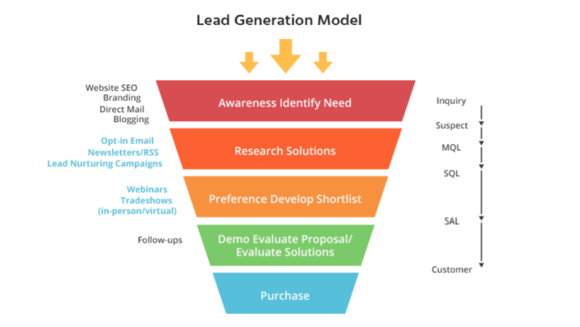

**2.1 Lead Generation Model**

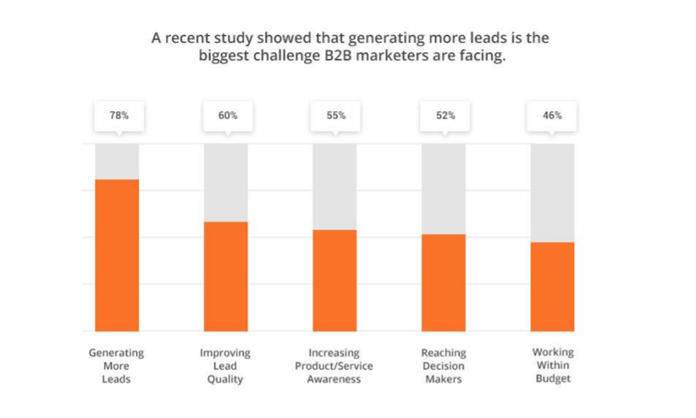

**2.2 Study on generating leads**

A recent study reveals that 78% marketers struggle with lead generation and more than 60% marketers say improving lead quality is their biggest challenge. Now, the big question here is how would you push through a large amount of high-quality leads and sales-ready prospects into your lead generation funnel? If you’re focused on boosting conversions, you’ll need to use lead generation strategies to keep the top of your lead funnel full without wasting your time or budget.

**2.4 Digital Marketing**

Digital marketing can be defined as the process of promoting of brands using digital distribution channels comprising internet, mobile and other interactive channels. The basic advantage in this form of advertising lies in its low-cost model Digital Marketing can be classified into Pull and Push marketing.

Pull digital marketing technologies involve the user having to seek out and directly grab the content via web searches. Web site/blogs and streaming media are good examples of this. In each of these examples, users have a specific link (URL) to view the content.

Push digital marketing technologies involve both the marketer as well as the recipients. Email, SMS, RSS are examples of push digital marketing. In each of these examples, the marketer must send the messages to the users for the message to be received

**Web Site Designing**

Value Prop through its tie up venture www.hanuinfo.com offers a complete package of affordable website design and ecommerce web development. From the initial process of taking inputs from clients, planning based on such inputs to final implementation and testing – all are done using latest web designing techniques and skills. Our services have the advantage of offering clarity in its design style, which is backed up with an easy and free flowing content and latest technical know-how. Not only we provide affordable web site design and ecommerce web development services but also search engine friendly designs. Our Service Includes

* Website Design
* Website Redesign
* Shopping Cart Web Design
* Detailed and Advanced Page Layout
* Custom Logo Design
* Banner Ads
* Custom Graphics Design using advanced design tools.

**Push Pull strategy:** A push-pull-system in business describes the movement of a product or information between two subjects. On markets the consumers usually "pull" the goods or information they demand for their needs, while the offerors or suppliers "pushes" them toward the consumers. In logistic chains or supply chains the stages are operating normally both in push- and pull-manner. The interface between push-based stages and pull-based stages are called push-pull boundary or decoupling point.

**Marketing:**

**Strategies in digital marketing**:

Two basic digital marketing strategies used by current and potential customers. These two types of digital marketing are called the “Push” and the “Pull.” Their methodology for providing information to customers works as follows:

**Push strategy**

* Another meaning of the push strategy in marketing can be found in the communication between seller and buyer.
* In dependence of the used medium, the communication can be either interactive or non-interactive. For example, if the seller makes his promotion by television or radio, it's not possible for the buyer to interact with.
* On the other hand, if the communication is made by phone or internet, the buyer has possibilities to interact with the seller.
* In the first case information is just "pushed" toward the buyer, while in the second case it is possible for the buyer to demand the needed information according to his requirements.
* Applied to that portion of the supply chain where demand uncertainty is relatively small
* Production & distribution decisions are based on long term forecasts
* Based on past orders received from retailer’s warehouse (may lead to Bullwhip effect)
* Inability to meet changing demand patterns
* Large and variable production batches
* Unacceptable service levels
* Excessive inventories due to the need for large safety stocks
* Less expenditure on advertising than pull strategy

**Pull strategy**

* In a "pull" system the consumer requests the product and "pulls" it through the delivery channel. An example of this is the car manufacturing company Ford Australia. Ford Australia only produces cars when they have been ordered by the customers.
* Applied to that portion of the supply chain where demand uncertainty is high
* Production and distribution are demand driven
* No inventory, response to specific orders
* Point of sale (POS) data comes in handy when shared with supply chain partners
* Decrease in lead time
* Difficult to implement

**Objectives of digital marketing**

* Lead generation/quick response /conversion
* Increase awareness/visibility/brand building
* Drive traffic/engage people/easily accessible
* Cost effective
* Effective to target youth

**Advantages of Digital Marketing:**

* Digital marketing has proven recession-proof in the times of global economic slowdown. Digital marketing strategies gave a respite to marketing companies during recession when traditional marketing tools proved helpless.
* Digital media marketing strategies are far more cost-effective than the traditional marketing media tools.
* Online marketing strategies don’t require long-standing commitments. Instead, online media marketing tools like PPC ads can be changed on a daily basis.
* Online media marketing output is easily trackable. Digital marketing media strategies have a high degree of measurability. Thus, designing a target-oriented digital media marketing program becomes easier.
* Digital media marketing has transformed the marketing industry. Online marketing includes use of mobile phone and internet technology provides a cheap medium to establish direct contact with the customers.
* Focused digital media marketing campaigns most likely attract the prospects that later convert into leads.

**Tools and benefits of digital marketing**:

* Digital Marketing in broader terms is the practice of promoting products and services using digital distribution Medium to reach to maximum consumers in a timely, relevant, personal and cost-effective manner.

**CHAPTER 3**

**PROJECT DESCRIPTION**

The recently have completed a 1-month product design internship at UNISOLUTIONS in BANGALORE. It was a rewarding experience that allowed me to gain valuable experience in the UX/UI field. I was immersed in various product design-driven projects, exposed to the digital design community and considered an integral member of a team of multi-disciplined, talented, creative and motivated individuals. This article aims to shed light on my experience as a design intern, and to impart a few words of advice for those planning on pursuing an internship in the future.

Developing a clean and simple website requires basic knowledge in different areas of web development.

**3.1 Domain Details**

**HTML:**

HTML is at the core of every web page, regardless the complexity of a site or number of technologies involved. It's an essential skill for any web professional.

HTMLprovides the basic structure of sites, which is enhanced and modified by other technologies like CSS and JavaScript.

**CSS:**

CSS stands for Cascading Style Sheets. This programming language dictates how the HTML elements of a website should actually appear on the frontend of the page.

CSS is used to control presentation, formatting, and layout.

**JavaScript:**

It is used to control the behavior of different elements. JavaScript is a more complicated language than HTML or CSS.

JavaScript is supported by all modern web browsers and is used on almost every site on the web for more powerful and complex functionality.

**PHP:**

Hypertext Preprocessor (or simply PHP) is a general-purpose programing language originally designed for web development. It is an HTML-embedded scripting language that is used to write web pages. It is commonly used to extract data out of a database on the server and present it on the Web page.

**SQL:**

SQL is an abbreviation for structured query language. SQL is a standardized query language for requesting information from a database.

Data Manipulation can be performed by using INSERT, DELETE and UPDATE command statements to add, update or delete data.

**3.2 PLATFORMS USED**

**BOOTSTRAP**

* Bootstrap is a free and open-source front-end web framework. It contains HTML and CSS-based design templates for typography, forms, buttons, navigation and other interface components, as well as optional JavaScript extensions.
* Unlike many earlier web frameworks, it concerns itself with front-end development only. Bootstrap is a web framework that focuses on simplifying the development of informative web pages .
* The primary purpose of adding it to a web project is to apply Bootstrap's choices of color, size, font and layout to that project.
* They provide additional user interface elements such as dialog boxes and tooltips.
* Each Bootstrap component consists of an HTML structure, CSS declarations, and in

and in some cases, accompanying JavaScript code.

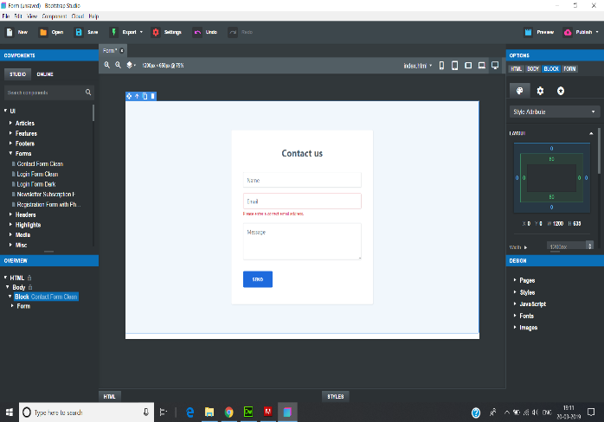

**3.1 Bootstrap Interface**

**ADOBE DREAM WEAVER:**

* Adobe Dreamweaver is a software program for designing web pages, essentially a more fully featured HTML web and programming editor. The program provides a what you see is what you get interface to create and edit web pages. Dreamweaver supports many markup languages, including HTML, XML, CSS, and JavaScript.
* As for human languages, it supports English, Spanish, French, German, Japanese, Chinese (both simplified and traditional), Italian, Russian, and many more.
* It was created by Macromedia in 1997 and developed by them until Macromedia was acquired by Adobe Systems in 2005.
* Adobe Dreamweaver CC is a web design and development tool that uses both a visual design surface known as Live View and a code editor.
* Standard features are used such as syntax highlighting, code completion, and code collapsing as well as more advanced features such as real-time syntax checking and code introspection for generating code hints to assist the user in writing code.

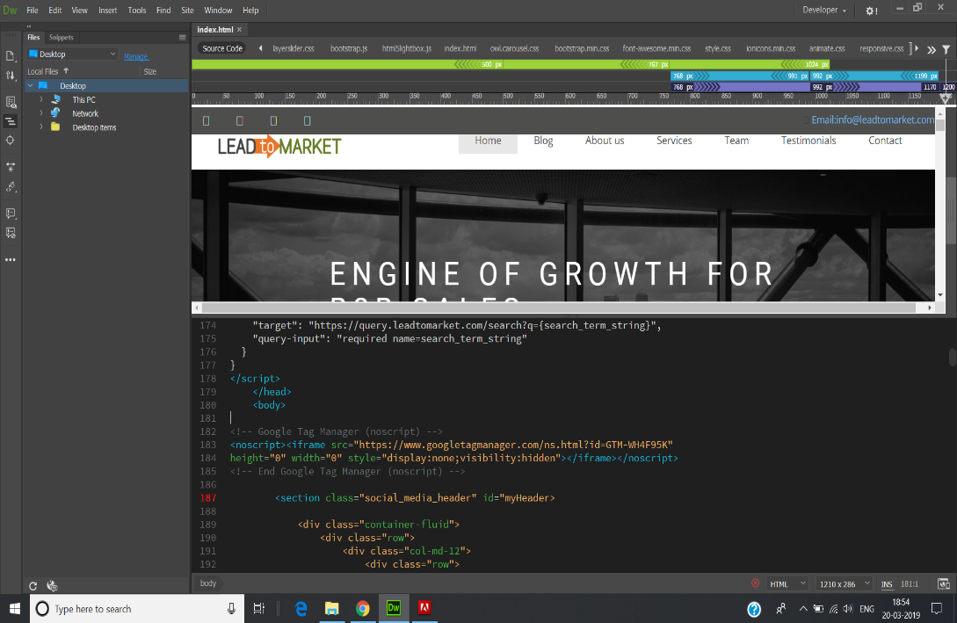

* 1. **Adobe Dreamweaver Interface**

**WAMP SERVER**

* WampServer refers to a software stack for the Microsoft Windows operating system, created by Romain Bourdon and consisting of the Apache Web server, OpenSSL for SSL support, MySQL database and PHP programming language.

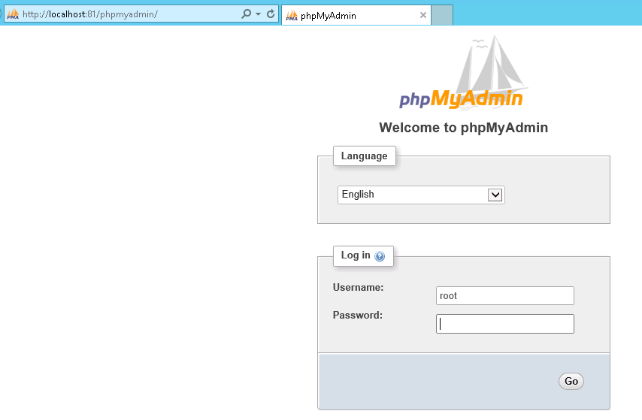

**3.3 Wamp Server Interface**

**3.3 Accelerated Mobile Pages**

* The **Accelerated Mobile Pages** (**AMP**) Project is a website publishing technology developed by Google.
* To make the website compatible to all the device we had the change the layout from fixed to liquid.
* The website was loading very slow in mobile to increase the speed we had to implement the AMP- Accelerated mobile page.
* AMP is supported by many different platforms, and it's compatible across all browsers.

### **Online Format**

AMP pages are published on-line and can be displayed in most current [browsers](https://en.wikipedia.org/wiki/Web_browser). When a standard webpage has an AMP counterpart, a link to the AMP page is usually placed in an [HTML tag](https://en.wikipedia.org/wiki/HTML_tag) in the [source code](https://en.wikipedia.org/wiki/Source_code) of the standard page. Because most AMP pages are easily discoverable by [web crawlers](https://en.wikipedia.org/wiki/Web_crawler), third parties such as search engines and other referring websites can choose to link to the AMP version of a webpage instead of the standard version.

### **AMP framework**

The AMP framework consists of three components: AMP HTML, which is standard HTML mark-up with [web components](https://en.wikipedia.org/wiki/Web_components); AMP JavaScript, which manages resource loading; and AMP caches, which serve and validate AMP pages. Most AMP pages are delivered by Google's AMP cache, but other companies can support AMP caches. Internet performance and security company [Cloudflare](https://en.wikipedia.org/wiki/Cloudflare) launched an AMP cache in March 2017.

### **Third party integration**

Any organization or individual can build products or features which will work on AMP pages, provided they comply with the AMP Project specifications. As of July 2017, the AMP Project's website listed around 120 advertising companies and around 30 analytics companies as AMP Project participants.

### **Performance**

Google reports that AMP pages served in Google search typically load in less than one second and use ten times less data than the equivalent non-AMP pages. CNBC reported a 75% decrease in mobile page load time for AMP Pages over non-AMP pages, while [Gizmodo](https://en.wikipedia.org/wiki/Gizmodo) reported that AMP pages loaded three times faster than non-AMP pages.

### **Parity with canonical pages**

Google has announced that as of February 1, 2018, it will require the content of canonical pages and those displayed through AMP be substantially the same. This is aimed at improving the experience of users by avoiding common difficulties with the [user interface](https://en.wikipedia.org/wiki/User_interface), and increase security and trust.

**3.4 DATABASE**

**Contact page**

* Created a Database for the contact form which we created using SQL queries.
* The creation of database was done using platform MySQL Wamp Server.
* Then to establish connection between the form and database we used php.
* Provided Meta title to each webpage so that it does not exceed 60bits to maintain the less loading time.

**CREATION OF CONTACT TABLE**

CREATE TABLE `contact` (

`name` varchar(20) NOT NULL,

`email` varchar(20) NOT NULL,

‘phone`varchar(20) NOT NULL,

`message` varchar(100) NOT NULL);

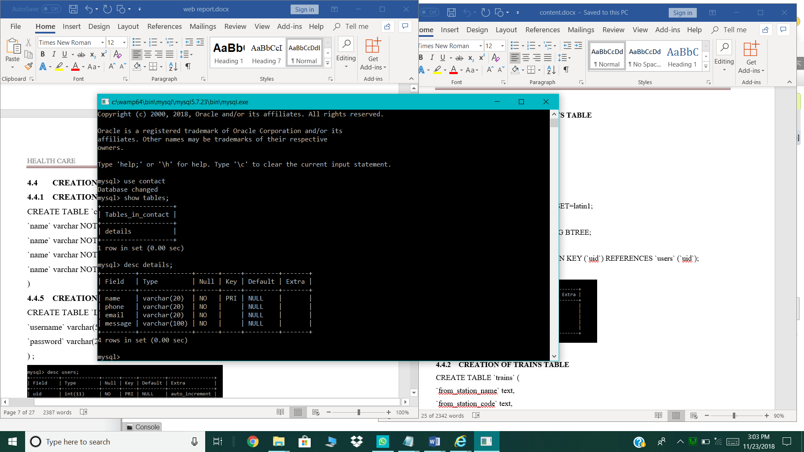

* 1. **Contact description**

**Code Snippet for Database Connectivity**

<?php

$servername = "localhost";

$username = "root";

$password = "";

$dbname = "contact ";

$conn = new mysqli($servername, $username, $password, $dbname);

if ($conn->connect_error) {

die("Connection failed: " . $conn->connect_error);

}

**View_contact.php**

</html>

<?php

error_reporting (E_ALL ^ E_DEPRECATED);

mysql_connect('localhost','root','');

mysql_select_db('contact');

?>

<!DOCTYPE html>

<html>

<title>Contact Details</title>

<style>

table{

border-collape:collapse;

width:100%;

color: #588c7e;

font-family:monospace;

font-size:25px;

text-align:left;

}

th {

background-color: #588c7e;

color:white;

}

tr:nth-child(even){background-color:#f2f2f2}

</style>

<body>

<table>

<tr>

</tr>

<tr>

<th>Your Name</th>

<th>Email Address</th>

<th> Phone Number</th>

<th>Your Message</th>

</tr>

<?php

$sql_sel=mysql_query("SELECT * FROM details");

while($row=mysql_fetch_array($sql_sel))

{

?>

<tr>

<td><?php echo $row['name'];?></td>

<td><?php echo $row['email'];?></td>

<td><?php echo $row['phone'];?></td>

<td><?php echo $row['message'];?></td>

</tr>

<?php

}

?>

</table>

</body>

</html>

**Results:**

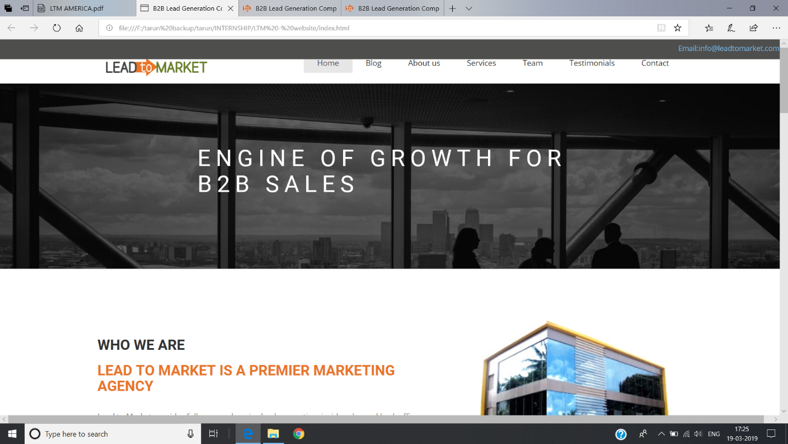

**Figure 3.5 :Welcome Page of Lead to market**

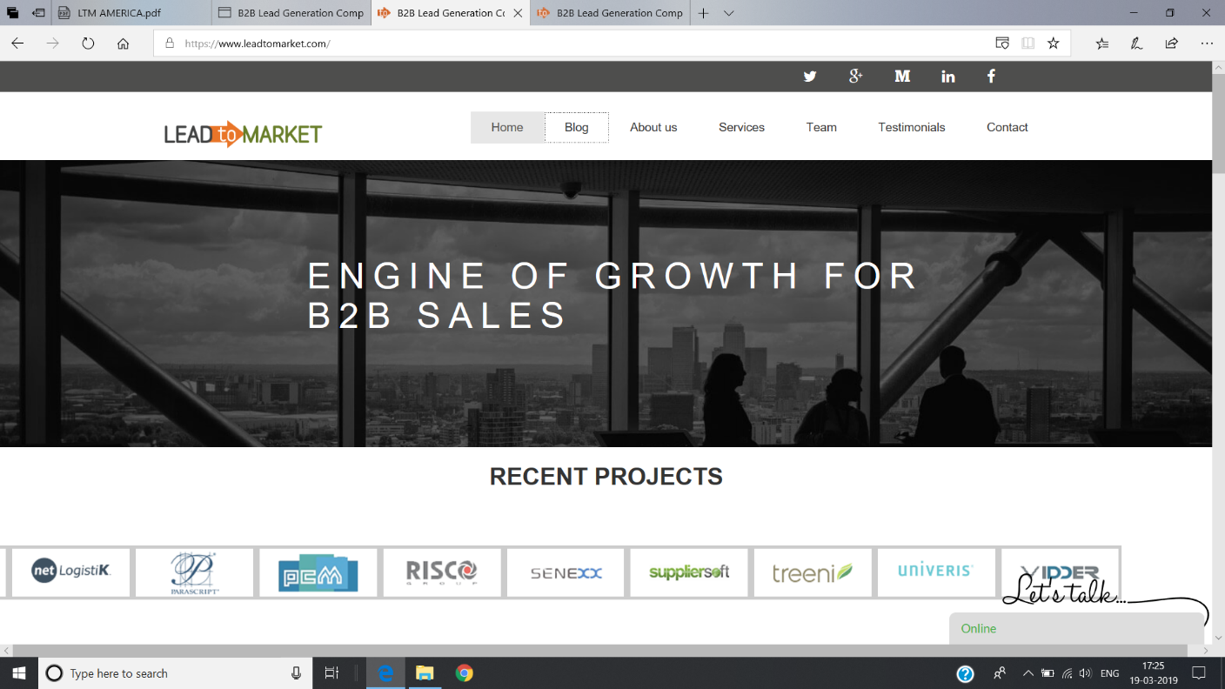

**Figure 3.6 :Updated Welcome Page**

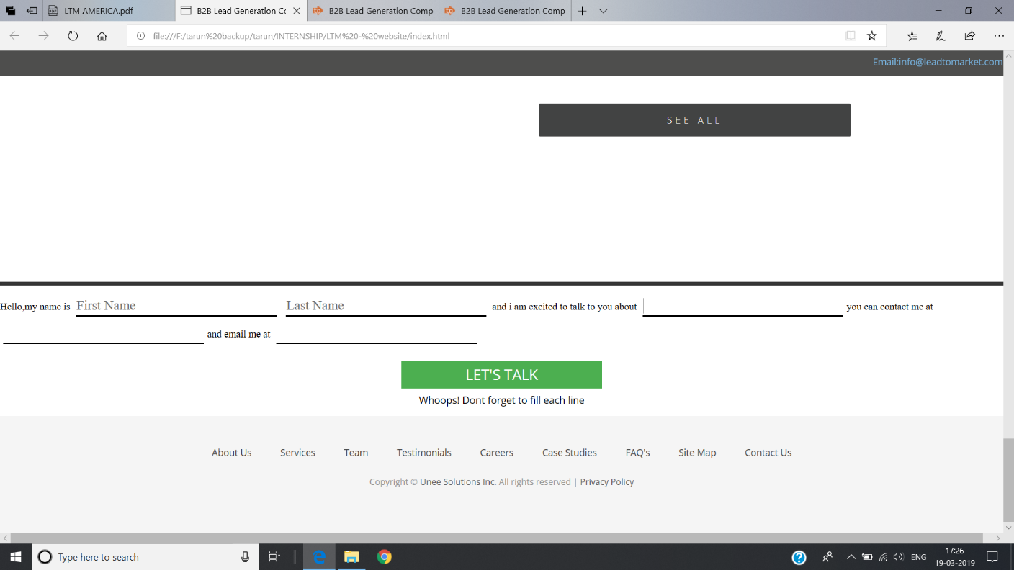

**Figure 3.7 :Contract Information Page**

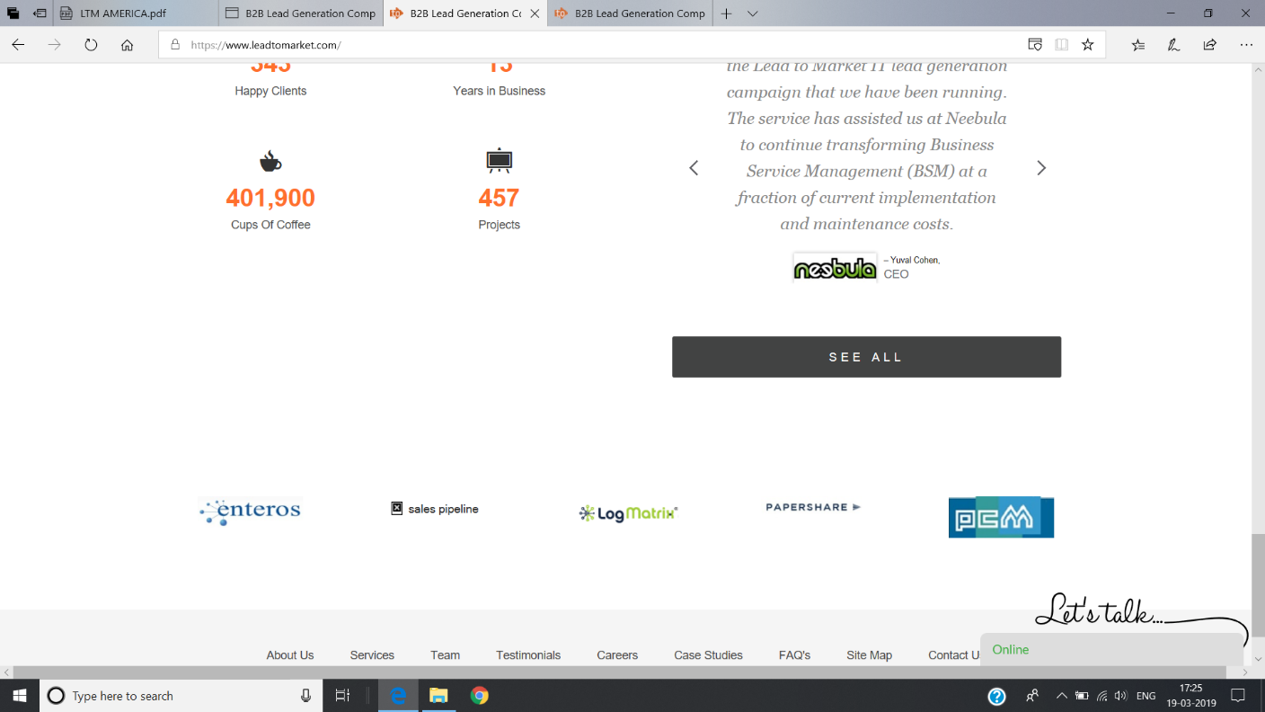

**Figure 3.8 :Updated Information Page**

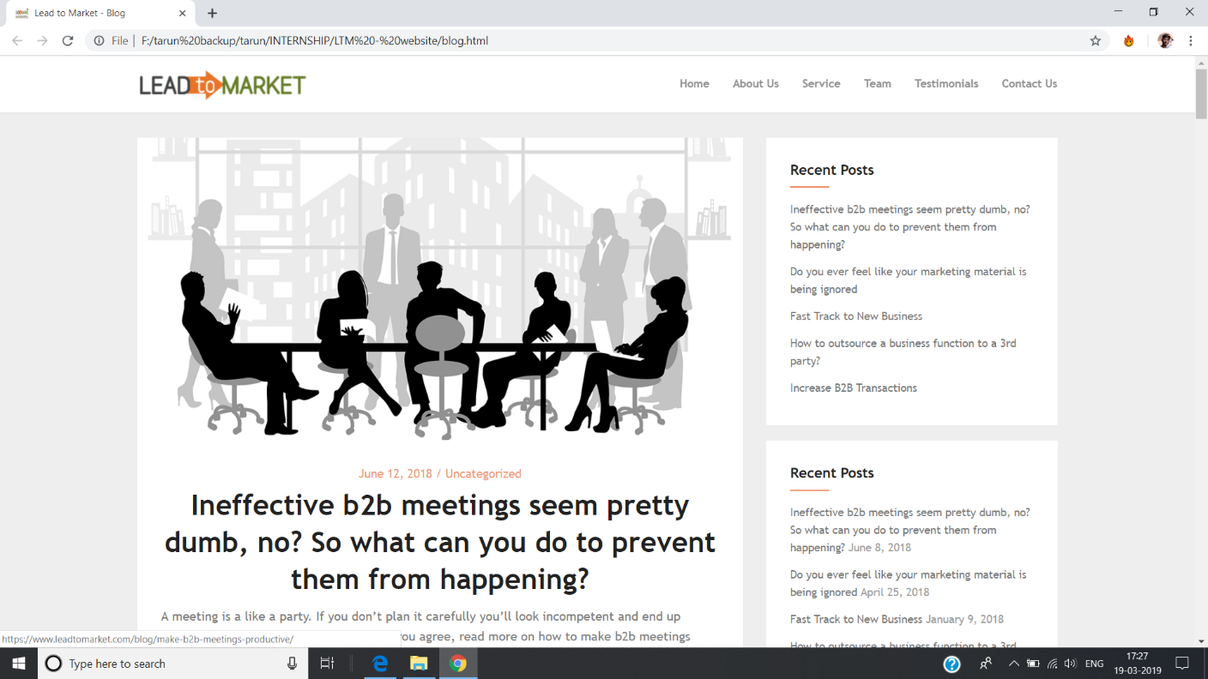

**Figure 3.9 :Testimonials Page**

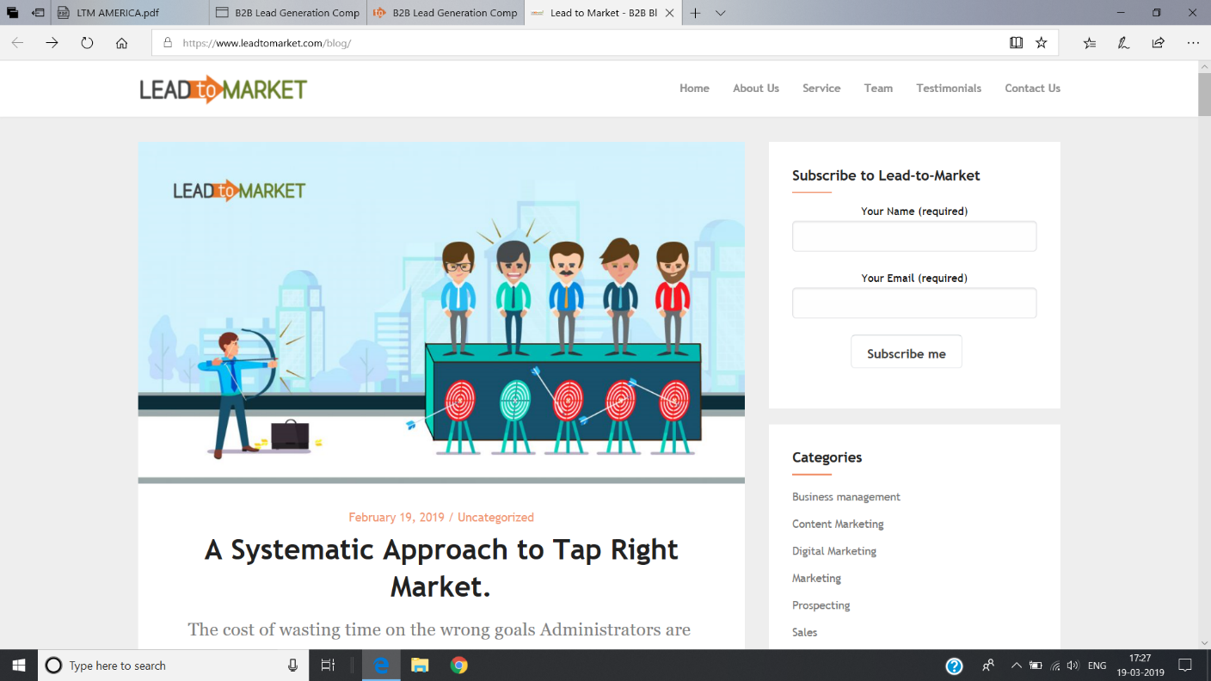

**Figure 4.1 :Updated Testimonials Page**

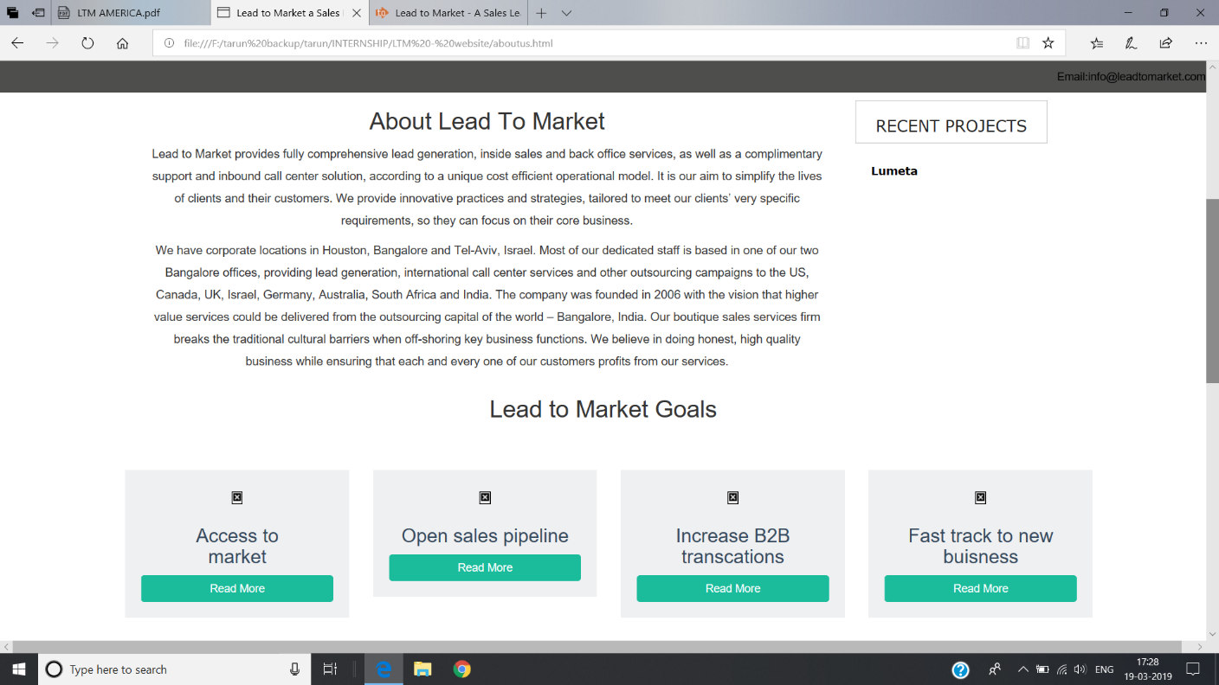

**Figure 4.2 :About Company Page**

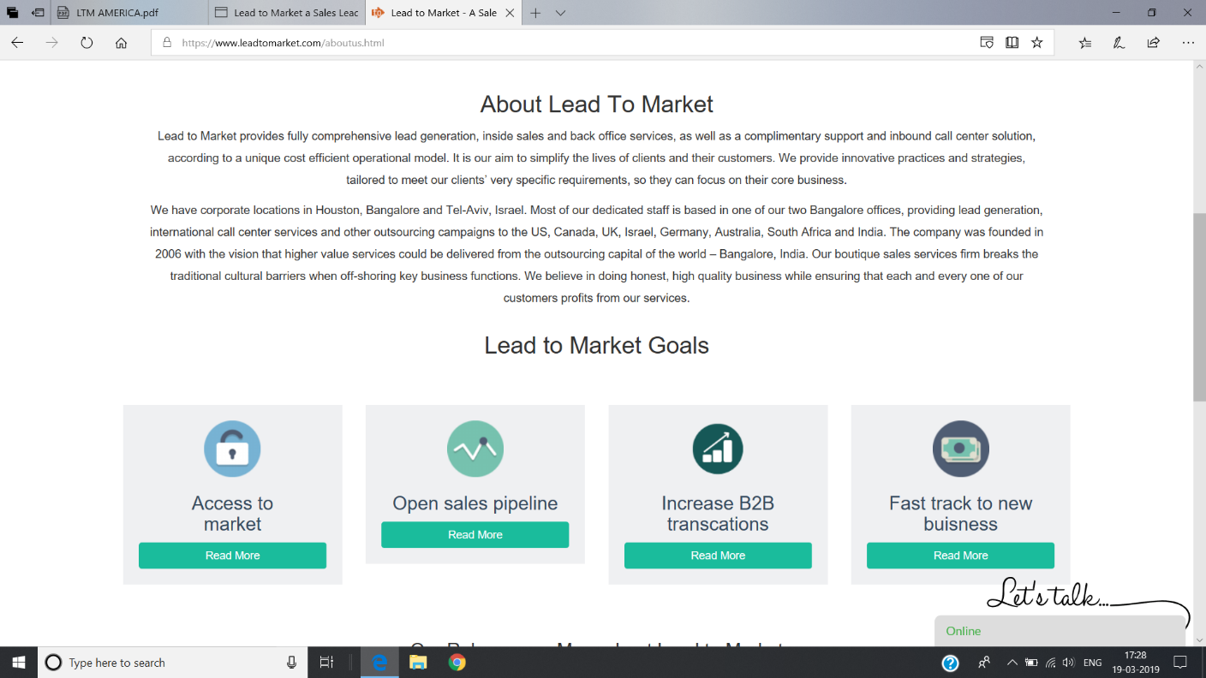

**Figure 4.3 :Updated About Company Page**

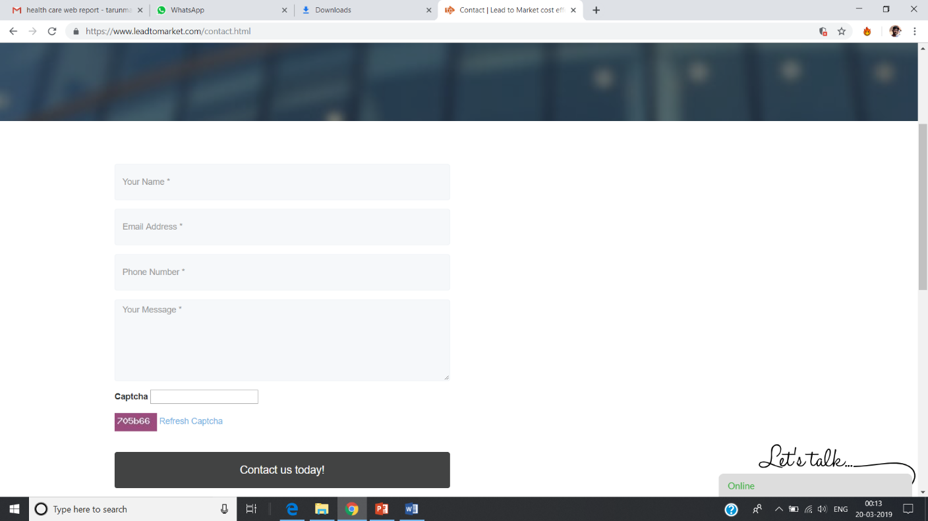

**Figure 4.4:Client Information Gathering Page**

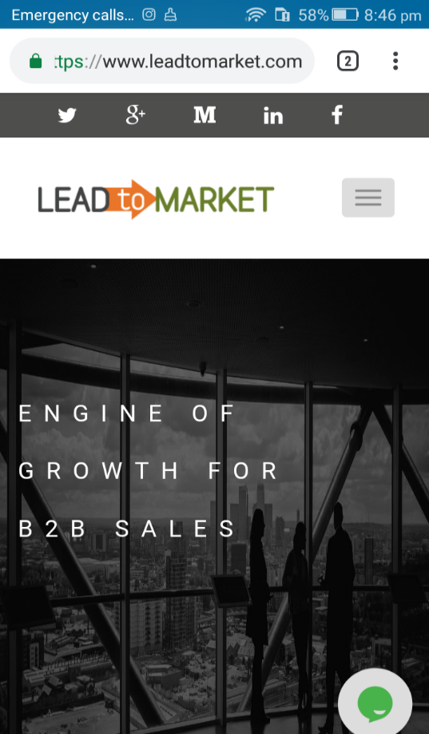

**CHAPTER 4**

**REFLECTION NOTES**

During the period of Internship in Uni-solution, Let to learnt about the fundamentals of B2B and implementation of webpages using PHP, CSS and HTML. This internship provided me with an opportunity to learn about new concepts in the field of front-end development and connecting front-end with the back-end.

The real time experience of an industry environment which are different from our institutional. This internship helped me develop team spirit and taught me how to work under deadlines. My liaising and communication skills became necessary and were honed better as necessitated by pragmatic demands.

Most importantly, The ability to enhance my skill set as an engineer. This internship has been instrumental in providing me the necessary exposure to face the corporate world. I believe that been able to take this knowledge with me throughout all the endeavors I undertake in my professional career.

**CONCLUSION**

Uni solutions have corporate locations in Houston, Bangalore and Tel-Aviv, Israel. Most of dedicated staff is based in one of two Bangalore offices, providing lead generation, international call center services and other outsourcing campaigns to the US, Canada, UK, Israel, Germany, Australia, South Africa and India. The company was founded in 2006.

During the period of internship, an integrated web application was implemented. This web application encompasses different skills and disciplines about the company.

It is our aim to simplify the lives of clients and their customers. Uni-solution provide innovative practices and strategies, tailored to meet our clients’ very specific requirements, so they can focus on their core business.

It provides fully comprehensive lead generation, inside sales and back office services, as well as a complimentary support and inbound call center solution, according to a unique cost efficient operational model. It is easy to use and is designed and developed to deliver real conceivable benefits thereby improving the quality of work. A user-friendly interface is provided so that it is easy to learn and to be used.

**REFERENCES**

[1] [https://www.leadtomarket.com](https://www.leadtomarket.com/)

[2]